Baby blanket « Whirlwinds »
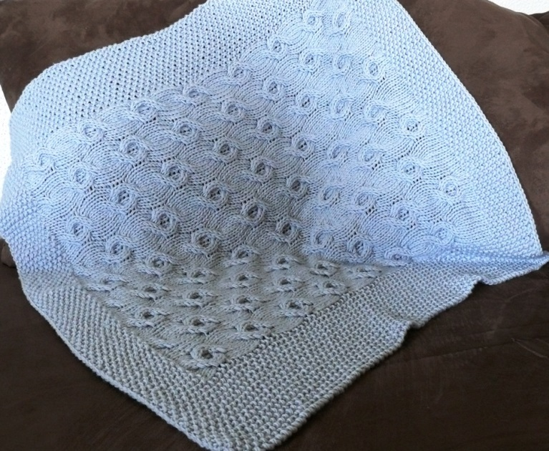

Materiall :
10 balls of wool Mérina, color “perle”.
Needles 7mm, cable needle,
If necessary: 2 stitch markers, a compter of rows.
Gauge (10cm x 10 cm) in moss stitch: 15 stitches /20 rows.
Points used :
Stocking stitch :
Row 1 (right side): knit.
Row 2 (wrong side): purl.
Repeat these 2 rows.
Moss stitch:
Row 1(right and wrong side): *knit 1, purl 1*, finish with knit 1.
Always knit this row. In case of change of the number of stitches, watch to oppose always the stitches of a row on the other one.
Twist :
Twist 1(T1) : On 4 stitches, slide the first two stitches on the cable needle, place it behind the work, knit place the following 2 stitches, then knit the 2 stitches of the auxiliary needle.
Twist 2 (T2): : On 4 stitches, slide the first two stitches on the cable needle, place it in front of the work, knit place the following 2 stitches, then knit the 2 stitches of the auxiliary needle.
k : knit.

Work:
Knit the threads double.
Cast on 102 stitches, knit 8 cm with moss stitch.
Then do 2 rows: 15 stitches using moss stitch, knit the following ones in stocking stitch , finish the row by 15 stitches in the moss stitch.
To facilitate the work, it is possible to position markers of stitch between the parts in the moss stitch and the center of the work.
I shall note stitches in the moss stitch of sides:MS15.
I shall note between [] the central part
*…* = repeat from *to*
Then :
Rows 1 and 9 (right side) :MS15, [*k2 , T1, k4 , T1, k2*, k2, T1, k2 ], MS15.
Rows 2, 4, 5, 6, 8, 10, 12, 13, 14 and 16 :MS15,[knit stitches as they appear], MS15.
Row 3 (right side) : MS15, [*T1, T2, k8*, T1, T2], MS15.
Row 7 (right side) : MS15, [*T2, T1, k8*, T2, T1] , MS15.
Row 11 (right side) : MS15, [*k8, T1, T2*,k8], MS15.
Row 15 (right side) : MS15 [*k8, T2, T1*,k8], MS15.
Repeat these 16 rows 7 times (that is a total of 112 rows),
Then make 2 rows as follows: 15 stitches in the moss stitch, knit the following ones in stocking stitch, finish the row by 15 stitches in the moss stitch.
Knit 8 cms of moss stitch on the totality of 102 stitches then bind off.
Bring in the threads, wash the work and block it if necessary.
Cut the threads to short.
Size:80cm/80cm.

