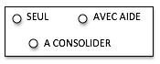

MOBILISER LE LANGAGE ECRIT

------------------------- Ecriture de mots croisés

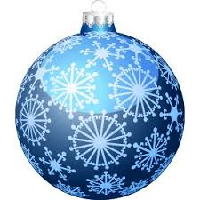

|  |  |
| --- | --- |
| Capture%20d’écran%202018-11-27%20à%2022.45.35.png | RENNE |
| Capture%20d’écran%202018-11-27%20à%2022.45.48.png | LUTIN |
|  | BOULE |
|  | CADEAU |
|  | ETOILE |

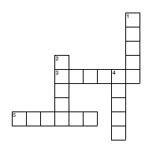



Capture%20d’écran%202018-11-27%20à%2022.45.48.png



