Dream viewer

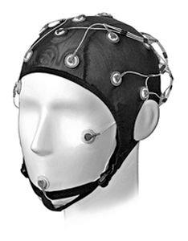Instruction manual

**OPERATING INSTRUCTIONS**

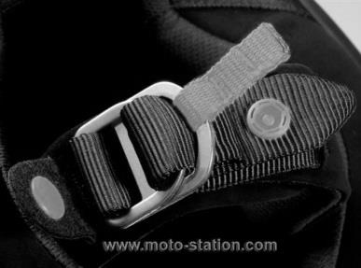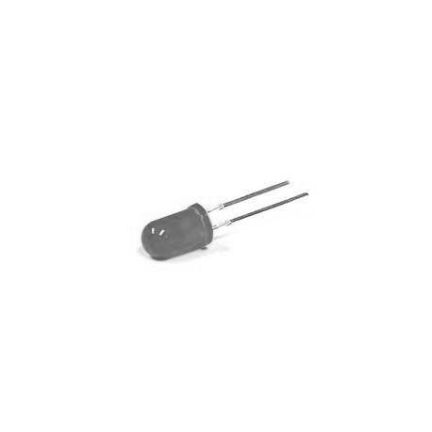

58965245215

Secure your helmet with the double loop to adapt it perfectly.

Put the helmet on your head when you want to save your dream.

Don’t forget to clear your helmet’s memory before a new use.

Look the LED situate near the battery if it do a green light it is load and if it do a red light it is not load.