midi

soir

soir

midi

soir

midi

midi

midi

soir

soir

soir

midi

soir

midi

Samedi

__________

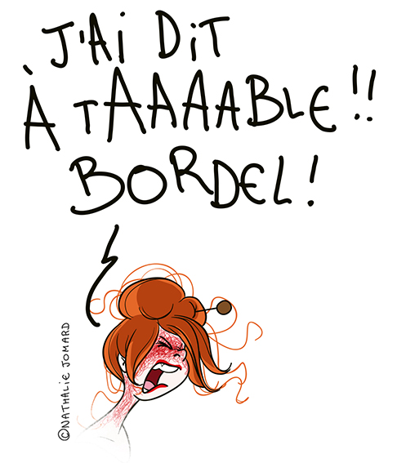

Dimanche

__________

**What’s for dinner ?**

**What’s for dinner ?**

Mardi

__________

Vendredi

__________

Jeudi

__________

Mercredi

__________

Lundi

__________